Research Internship

Interference Alignment for SC-FDMA Systems with Widely Linear Filtering

Mohamed Soliman

Supervisor:

Dipl. - Ing. Uyen Ly Dang

Prof. Dr. - Ing Wolfgang Gerstacker

October 22, 2017

# Abstract

We consider transmit beamforming for single–carrier frequency–division multiple access (SC–FDMA) transmission over frequency–selective multiple–input multiple–output (MIMO) channels, assuming that the data symbols are mapped into points of fixed signal constellations, a transceiver structure employing widely linear (WL) filters, rather than linear ones, is proposed in order to exploit the statistical redundancy of some constellations, i.e., the correlation between the signals and their conjugate version. WL filters linearly and independently process both the in-phase and the quadrature components of the input signals and, with a limited increase in the computational complexity, allows one to improve the system performances.

# Introduction

One of the main problems for wireless multimedia applications is the demand for higher data rate which leads to a wider transmission bandwidth. With the use of wider bandwidth comes through the issue of frequency selectivity thus the channel becomes severe alongside the inter-symbol interference (ISI). One way to solve frequency selective fading is using multi-carrier techniques which subdivide the channel into smaller sub-bands, or sub-carriers. Orthogonal frequency division multiplexing (OFDM) is a multicarrier modulation technique which uses orthogonal subcarriers to convey information. To simplify the equalization process, each sub-carrier is seen as flat fading channel since the bandwidth of a subcarrier is deigned to be smaller than the coherence bandwidth. On the other hand, in the time domain, OFDM resolves the problem of ISI by splitting a high-rate data stream into lower-rate data stream which is transmitted in parallel. However, OFDM has its disadvantages: high peak to average power ratio (PAPR), high sensitivity to frequency offset and the spectral nulls in the channel.

## SC-FDMA

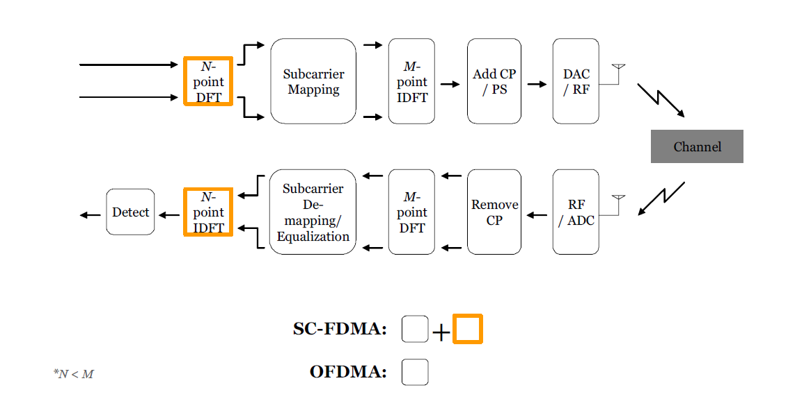

Figure 1

Single carrier frequency division multiple access (SC-FDMA) system which is a newly developed multiple access scheme adopted in the uplink of 3GPP Long Term Evolution (LTE), has drawn great attention as an attractive alternative to OFDMA, especially in the uplink communications where lower PAPR greatly benefits the mobile terminal in terms of transmit power efficiency. Figure [] shows a block diagram of an SC-FDMA system. Basically, SC-FDMA system follows the same principle as OFDMA of using inverse discrete Fourier transform (IDFT) to transmit data symbols and discrete Fourier transform (DFT) to receive data symbols, with additional form of precoding by using DFT at transmitter and IDFT at receiver. The overall transmit signal is a single carrier signal, PAPR is inherently low compared to the case of OFDMA which produces a multicarrier signal.

The transmitter first groups the modulation symbols into blocks that contains N symbols. Then it performs the N-point DFT to produce frequency domain representation of the input symbols. After that, it maps each of the N symbols to M orthogonal sub-carriers that can be transmitted. Usually, M is greater than N (M>N). And finally, as in OFDMA system, the M-point IDFT transform the subcarrier amplitudes to the complex time domain signal. After the transmitter finishes with these blocks, it inserts a set of symbols as it called cyclic prefix (CP) in order to provide a guard interval that used to prevent inter-block interference (IBI) due to multipath propagation. Essentially, CP is a copy of the last part of the block, which is added to the start of the block as it acts like a guard interval between successive blocks. Usually, the length of CP is greater than the maximum delay spread of the channel or roughly the length of the channel impulse response, which will solve the problem of IBI. Also, by using CP as a copy of the last part of the block, it converts a discrete time linear convolution into a discrete time circular convolution. After the transmitter finishes with adding CP, it performs pulse shaping as a linear filtering operation in order to reduce the out of band signal energy.

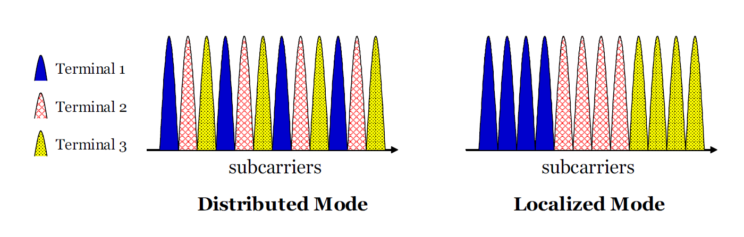

Figure

Explain sub-carrier mapping

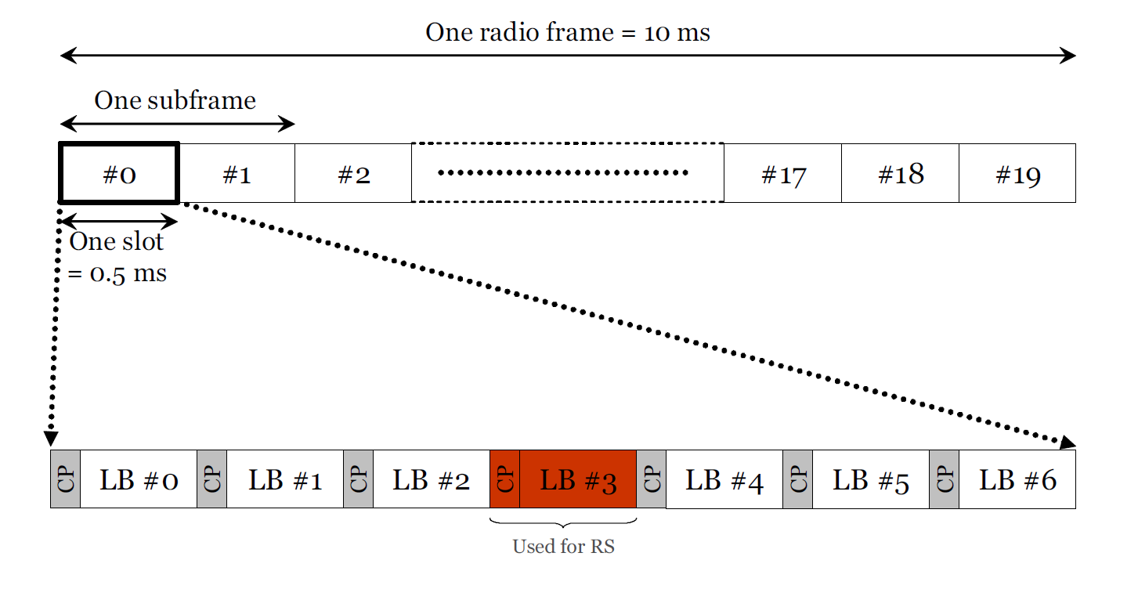

Figure

Explain how the radio frame works.

## Interference alignment

## Widely linear filter

WL filtering generalizes linear filtering by linearly processing the in-phase and quadrature components of the input signals separately, without requiring a significant increase in the computational complexity.

# System Model

Equations for SCFDMA and WL

# Minimum mean square error interference alignment

Equations for MMSE that’s been used in simulations

## MSE minimization of strictly linear transceiver

Equation

## MSE minimization of widely linear transceiver

Equations

# Simulation results

Figures and observations

# Conclusion

What do we add and learn